- DSC 680: Week 5
- Data Science Competition
- Martin Hoehler
- 4/19/26
Spaceship Titanic Kaggle Competition
Introduction
For this week’s assignment, I entered my first Kaggle competition. I picked the “Spaceship Titanic” (Kaggle, 2022) competition because it is designed for beginners. The contest creates an imagined spaceship that hits a space-time anomaly and transports a group of passengers to another dimension. I need to use the damaged computer records to predict which passengers were transported.
Data Prep and Feature Engineering
There were a lot of missing values in both the training and test sets. Some of it could be filled in with reasonable assurance, (like if a person was in CryoSleep, they weren’t likely to be spending money at the spa.) In other cases, I had to use averages to fill in missing values. It was possible to extract a “Group number” from the passenger ID, and this gave you information about cabin mates to find missing values for cabins. Features were also one-hot encoded to prepare for modeling.
Modeling Approach
I went from simple to more expressive, starting with Logistic Regression, then Random Forest, XGBoost, Light GBM and finally CatBoost. Al were trained on a five-fold StratifiedKFold cross-validation Scheme. The CatBoost performed best, so I fine-tuned it with Optuna.
Model | Mean Accuracy | Std Dev | Notes
Logistic Regression | 0.78235 | 0.0053 | Linear baseline
Random Forest | 0.80214 | 0.0080 | Bagged trees; nonlinear benchmark
XGBoost | 0.80640 | 0.0068 | Gradient boosting baseline
LightGBM | 0.80076 | 0.0050 | Fast boosting; slightly underperformed XGB
CatBoost (Base) | 0.81433 | 0.0037 | Best base model
CatBoost (Optuna Tuned) | 0.81928 |  | Best overall; tuned with Optuna

Results and Interpretation
The Optuna-tuned CatBoost model was used for our submission table, and achieved a score of .80523, which gave me a rank of 517 on the leaderboard. It’s a 2-month rotating leaderboard, but I was still very excited to see my name on the board.
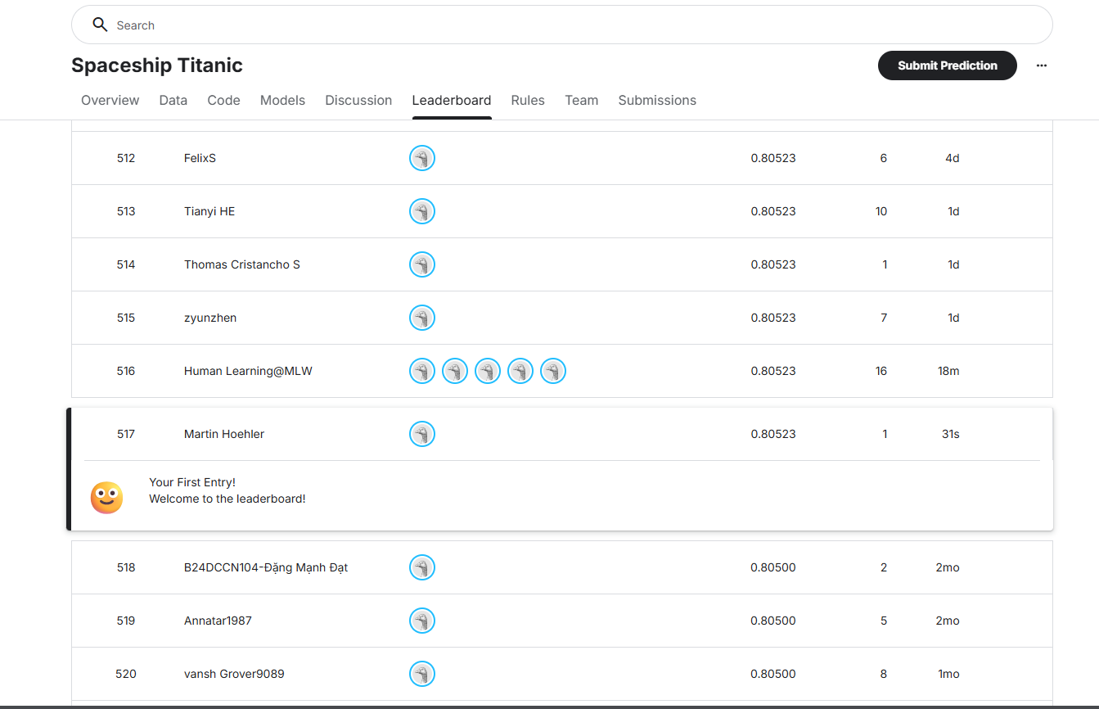
I did some SHAP analysis to see what features were contributing, and found that spending habits were one of the biggest drivers. Some spending categories made you more likely to be teleported, and some made you less likely. There was also predictive power behind the deck you were on and the planet you came from.
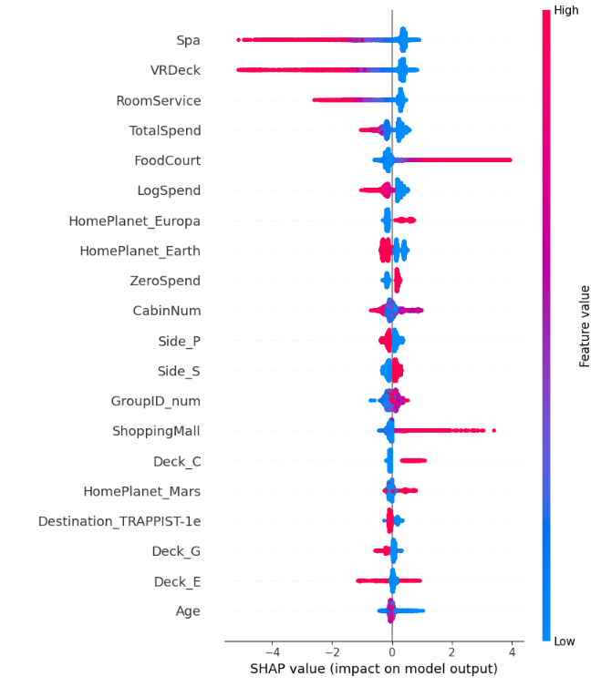
Conclusion
I’ve been browsing Kaggle competitions since I started my degree, but I’ve never taken the time to try one. Part of it was being busy with class work, but part was a confidence issue. It was helpful to have this as an assignment to push me to try it out. I’m excited to see that I now have the knowledge to run a full-length data modeling experiment through to completion. Placing on the leaderboard was also a nice confidence boost. I will be using this project in my portfolio, because it shows that my work product stands up against world-wide analysts.
References
Kaggle. (2022). Spaceship Titanic [Machine learning competition]. Kaggle. https://www.kaggle.com/competitions/spaceship-titanic/overview

